16 – Worksheet – Inheritance and Polymorphism

Construct the following using OO and polymorphic techniques:

* Shape
* Square, circle, triangle, hexagon, pentagon
* Area, perimeter, draw (render)
* Cube, cylinder, other polyhedral
* Surface area, volume

Or

* HTML tags
* Pretty print / render() method

<html>

  <head></head>

  <body>

    <h1>Title</h1>

    <div>

      <p>

        Something

      </p>

     [… etc …]

  </body>

</html>

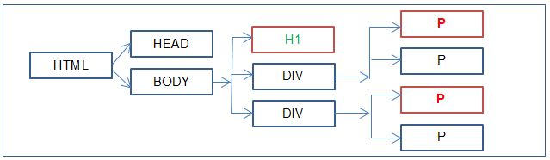

It’s up to you how you wish to code this, but this is my version:

|  |  |
| --- | --- |
|  |  |

I create a bunch of HTML tags, then I add them to each other creating a tree of objects. Then each of them will render themselves to the screen.